**TPA PROJECT**

**Login Screen:**

Login screen will have following users

1. Admin
2. Underwriter (Only view)
3. Claims user(Only view)
4. Broker(Only view)
5. Agents, (Only View)
6. Direct Sales
7. Branches
8. Client User (Only View)

I) Admin

II) Underwriter (Only view)

III) Claims user(Only view)

IV) Broker(Only view) ba001

V) Agents, (Only View) ag001

Direct sales mkt001

Branches sa001,

VI) Client User (Only View)

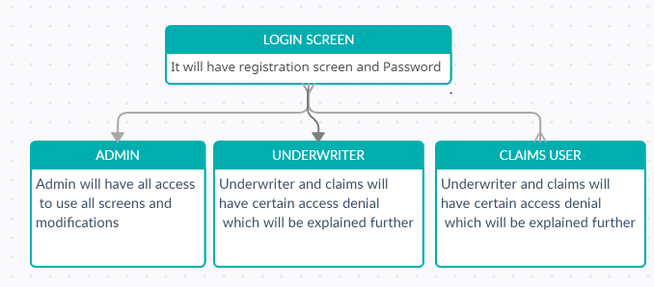

**Registration Screen:**

This screen should have all basic fields for registering the user.

Only Admin will have access to register a user.

There may be more number of users under a particular user. Unique code should be generated for a particular user.

**Forgot Password:**

Basic functionalities of Forgot password must be placed.

**MODULES**

The modules of the project placed below

1. **Underwriting module**
   1. Dashboard
   2. Master screen
   3. Quotation Builder -Draft No
   4. Policy Issuance – Policy No
   5. Endorsements – Already Developed
   6. Medical Card Issuance --
   7. Financial Document – C/D note
2. **Claims Module**
   1. Will be discussed widely once we complete Underwriting module
3. **Administration Module:**
   1. Administrator will have all access to all screens.

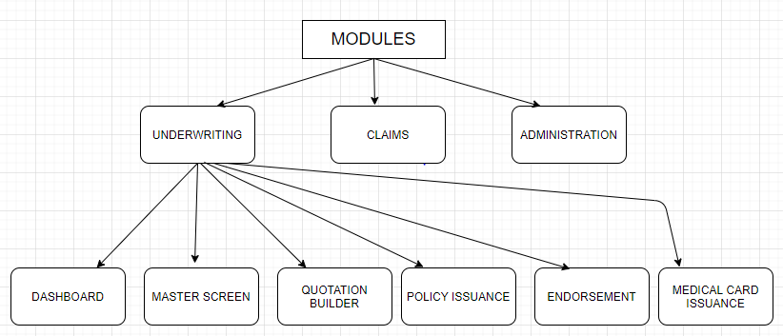

**I.a) DASHBOARD:**

Dashboard will have all the following menus

1. Admin user dashboard => Admin will have all access to use Underwriting and claims data.
2. Underwriter Dashboard
3. Claims Dashboard
4. Producer Dashboard

Maps :

1. Quotation

**I.b) MASTER SCREEN:**

Master screen is the base of project.

Data in the underwriter module and claims module will be accessed using the Master page.

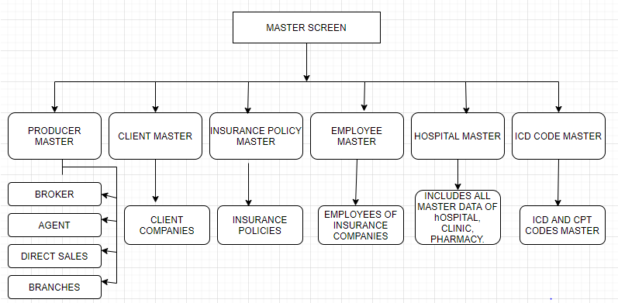

**PRODUCER MASTER:**

It will have Broker, Agents, Direct sales, and branch master. There may be limitless users in all producers.

All existing data of producer will be uploaded and there should be provision of adding new producer.

Auto generation unique code should be generated for each producers and members.

EG: Broker => BA0001

Agents => AG0001

Direct Sales => SA0001

Branches => BR0001

**CLIENT MASTER:**

Client master will have all client companies of Insurance company.

All existing data of clients will be uploaded and there should be provision of adding new client.

Auto generation unique code should be generated for each client.

EG: CL0001

**INSURANCE POLICY:**

Insurance policy master will have all Insurance policies of client company.

All existing data of Insurance policy will be uploaded and there should be provision of adding new Insurance policy.

Auto generation unique code should be generated for each Insurance policy.

EG: P/004/01/20/3101/00001

Whereas P indicates Policy

004 = Company code

01 = Branch

20 = YEAR

3101 = Product code

00001 = Sequence number

**EMPLOYEE MASTER:**

It has all employee detail of a client company.

All existing data of employees will be uploaded and there should be provision of adding new employee.

Auto generation unique code should be generated for each employee.

EG: Code will be generated according to company name. If client company name is **GLOBAL GYPSUM BOARD** then it will be **GGB001**

**HOSPITAL MASTER:**

It has master data of HOSPITAL, PHARMACY and CLINIC.

All existing data of hospitals will be uploaded and there should be provision of adding new hospital.

Auto generation unique code should be generated for each hospital.

**ICD MASTER:**

ICD and CPT codes will be provided to you from us.

**I.C) QUOTATION BUILDER:**

Details As already provided.

Details of all IP and OP benefits, Co-pay, deductible, pool limits, per claim limits, per visit limits, Annual limit, sub-limits.

It should have provision for configuring/deleting/customizing new/existing benefits with all controls. These accesses should be only for ADMIN.

Once completing all fields draft number will be created.

If all details checked by admin draft will be approved.

**Format of draft number is**

D/004/01/20/3101/00001

Whereas D indicates draft policy number

004 = Company code

01 = Branch

20 = YEAR

3101 = Product code

00001 = Sequence number

**I.D) POLICY ISSUANCE:**

Only approved quotation will be approved. And that’s how draft number is converted into policy number.

P/004/01/20/3101/00001

SA001 => 5000

**I.E) POLICY ENDORSEMENT:**

It will be linked with the application which is already developed by Totalligent.

**I.F) MEDICAL CARD ISSUANCE:**

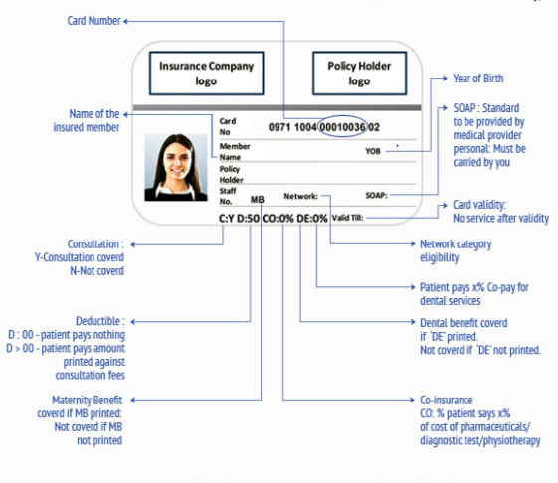

For each and every employee card has to be generated in the below given format.

When User clicks card generation E-card will generated in PDF format that will be taken printout by end users.

(valid till

Broker logo)

DASH BOARD: Jan 2021 - Dec 2021

Admin: Dropdown to check particular user=> Agent(Ag005), Broker(BA001), Direct(NULL), Branch(HO, Seeb, Salalah).

No of policies: 100 (2019)

Quotation Drafted : Draft number 15 (2019)

Policy Issued : 15 (2019)

Policy Lost : 10(2019) => Quotion builder status => Pending, Lost

Maps:

No of polices & No of quotation & Policy issued & Policy Lost

No of polices & Total Premium & Total lost premium

Total Earnings.

PIE chart- Producers list

Recent data